

Smart Campus Navigator: A Hierarchical Heuristic-Based Study Space Finder
Group Members
Saad Nasir …… 23L-2625
Ibrahim Moeed …… 23L-2602
Emad Rafique …… 23L-2604

Introduction & Motivation

Students at FAST-NUCES Lahore frequently face prolonged gaps between classes due to faculty availability and room scheduling constraints. Currently, the library (E-Block) is the primary indoor study location, however it strictly prohibits group discussions, and its private reservation rooms are consistently overbooked.
With no dedicated common rooms for boys, students are often forced to study outdoors. This presents significant challenges, including environmental distractions, limited seating, and extreme weather conditions during Pakistan's long summers. This project aims to solve this problem by developing an AI-driven tool that parses the university's official Excel Timetable to identify vacant classrooms in real-time. By modelling the campus as a multi-level graph, the system will guide students to the nearest available "group-study-friendly" room using informed search algorithms.

Literature Review

The challenge of navigating complex university environments and optimizing the use of limited academic space has led researchers to explore various Artificial Intelligence (AI) frameworks. Finding a vacant study space in a high-density campus like FAST-NUCES requires a system that can handle dynamic constraints and indoor architectural complexities where traditional GPS fails. The following review synthesizes insights from five key scholarly works that investigate indoor navigation, hierarchical searching, and smart resource management.
Kasim et al. [1] provided a foundational examination of indoor navigation using the A* algorithm within a faculty of computer science. Their research demonstrated that modeling a building’s layout as a graph of nodes (rooms) and weighted edges (corridors) is the most effective way to provide pathfinding in environments where satellite-based positioning is unavailable. The study concluded that the A* algorithm, by utilizing a heuristic function to estimate the distance to a goal, significantly outperforms uninformed search methods in terms of computational efficiency and path optimality. This supports our project’s core decision to utilize A* as the primary search engine for the FAST-NUCES campus.
Similarly, Wang et al. [2] addressed the issue of computational overhead in large-scale navigation through the Hierarchical A-Star (HAS) algorithm. By dividing a massive map into a tiered hierarchy such as zones, buildings, and individual rooms, the search space is drastically reduced. Their findings revealed that HAS can find optimal paths while expanding significantly fewer nodes than a standard flat-graph search. This directly justifies our proposed Hierarchical Graph Structure, which organizes the FAST campus into three distinct tiers: Building Nodes, Floor Nodes, and Room Nodes, ensuring the system remains responsive even as the complexity of the campus graph increases.
The practical necessity of such systems is further emphasized by Straub [3], who detailed the implementation of the "Seatfinder" utility at the Karlsruhe Institute of Technology (KIT). This real-world application was developed to solve the exact "pain point" faced by students: the time consuming search for available study desks during peak hours. Straub’s work highlights that providing students with real time occupancy visibility improves campus productivity and reduces the frustration associated with overbooked common areas like libraries. This aligns with our motivation to provide a tool that bypasses the limitations of the E-Block library by identifying vacant classrooms across the entire campus.
Advancing the technical implementation, Chen et al. [4] explored an improved A* algorithm that incorporates variable traversal costs. Their research suggests that a navigation system should not only consider physical distance but also the effort required to traverse different paths, such as stairs versus flat hallways. By assigning higher weights to vertical transitions, their model provides paths that are more human-centric and realistic for a student on a multi-floor campus. Our methodology adopts this approach by assigning specific cost units (e.g., 5 units for stairs vs. 1 unit for corridors) to ensure our AI recommends the easiest path, not just the shortest one.
Finally, the project ClassSync [5] contributes a resource management perspective by linking AI powered scheduling with classroom vacancy detection. The study investigates how data driven scheduling can identify wasted resource hours and dynamically reallocate space. The authors advocate for systems that can parse existing academic timetables to provide real time updates on room status. This research provides the technical validation for our plan to use the university’s excel timetable as a live knowledge base, turning a static document into a dynamic input for our search agent.
When viewed collectively, these studies demonstrate a convergent trend toward "Informed" and "Hierarchical" search strategies for smart campus management. While Kasim [1] and Chen [4] provide the algorithmic foundation for A*, Wang [2] provides the structural logic for our hierarchical mapping. Meanwhile, Straub [3] and ClassSync [5] provide the social and data driven justification for our tool. By synthesizing these approaches, the Smart Campus Navigator addresses a localized problem at FAST-NUCES Lahore through a technically rigorous AI framework that prioritizes efficiency, human effort, and real time utility

Proposed Methodology

Data Acquisition (The Timetable Engine)
The project will use the official Spring 2026 Timetable as a Knowledge Base.
- Parsing: Using the pandas library, we will extract room availability for the current day and hour.
- Goal States: All rooms marked as "Free" in the current time slot will be flagged as Goal Nodes in our graph.

Environment Modeling (Hierarchical Graph)
To handle the lack of precise distances, we will model the campus using a three-tier hierarchical graph based on the student-provided map:
- Tier 1: Building Nodes: Major blocks (A, B, C, D, E, F)
- Tier 2: Floor Nodes: Specific levels within buildings (Basement, Ground, 1st, 2nd, 3rd).
- Tier 3: Room Nodes: Individual classrooms (e.g., CS-1, Lab-5, F-201).

Cost Units (Edge Weights):
- 1 Unit: Intra-floor movement (Room to Room).
- 5 Units: Inter-floor movement (Using Stairs).
- 15 Units: building-building movement

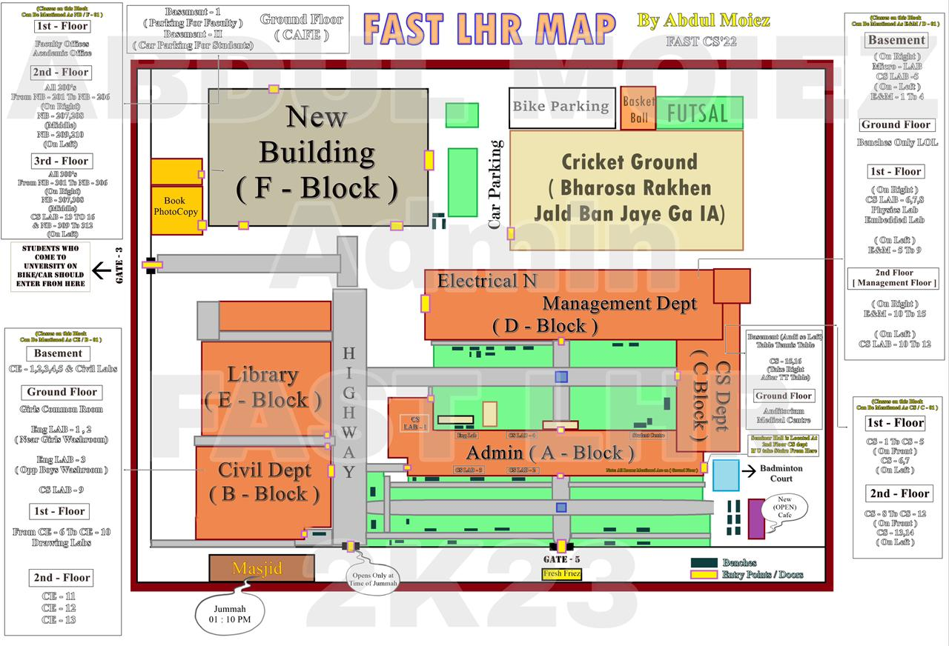
Fig. 1. Student curated logical topology of FAST-NUCES Lahore campus.

Search Algorithm Implementation & Comparison
The search process begins with the acquisition of the user’s Starting State. The user inputs their current location via a dropdown interface, which is then translated into a starting node on our campus graph. The system then identifies all currently available rooms as Goal States via the timetable engine and executes the search algorithms to find the optimal path. We will implement and compare three search strategies studied in the course:

- A* Search: Using a custom heuristic

- Uniform Cost Search (UCS): To find the mathematically shortest path without a heuristic.

- Breadth-First Search (BFS): To demonstrate the inefficiency of uninformed search in a large multi-floor graph.

Comparison Metrics:
- Path Cost: Does the algorithm find the optimal (lowest cost) route?
- Nodes Expanded: How many rooms/corridors does it explore before finding the goal?
- Execution Time: Which algorithm runs fastest?

Heuristic Discovery
The performance of A* search depends heavily on the quality of the heuristic function. We will research and experiment with different heuristic approaches to find the most informed one for our campus layout. We will test each heuristic by running A* on multiple start to goal scenarios and comparing the number of nodes expanded. The heuristic that results in the fewest node expansions while still guaranteeing optimal paths (admissibility) will be selected as our final heuristic. This experimentation ensures our A* implementation is as efficient as possible for the FAST campus navigation problem.

References

[1] S. Kasim, L. Y. Xia, et al., "Indoor Navigation Using A* Algorithm," in Proceedings of the International Conference on Soft Computing, 2016.
[2] H. Wang and J. Zhou, "HAS: Hierarchical A-Star Algorithm for Big Map Navigation in Special Areas," Journal of Software, vol. 9, no. 9, pp. 2427-2434, 2014.
[3] R. Straub, "Seatfinder - Available Study Spaces at KIT-Bibliothek," Karlsruhe Institute of Technology (KIT), Tech. Rep., 2024.
[4] K. Chen, "An Improved A* Search Algorithm Applicable for Campus Navigation," SRMIST Research Repository, 2022/2025.
[5] JETIR, "ClassSync: An AI-Powered Smart Classroom Management System for Automated Scheduling," Journal of Emerging Technologies and Innovative Research (JETIR), vol. 11, no. 2, 2024.

